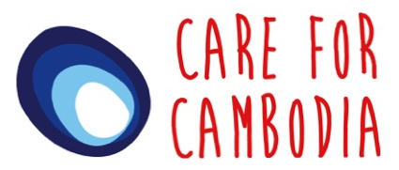
Alternative
Gifts
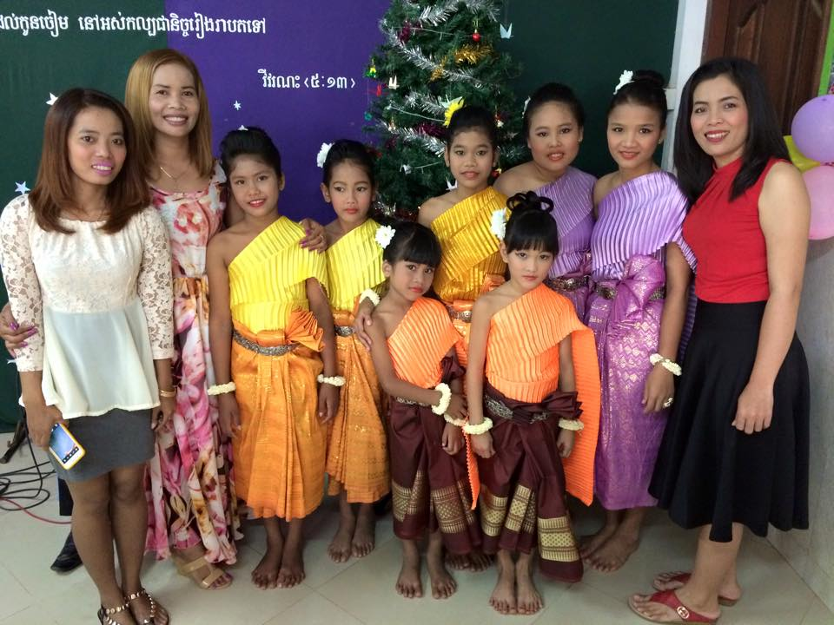
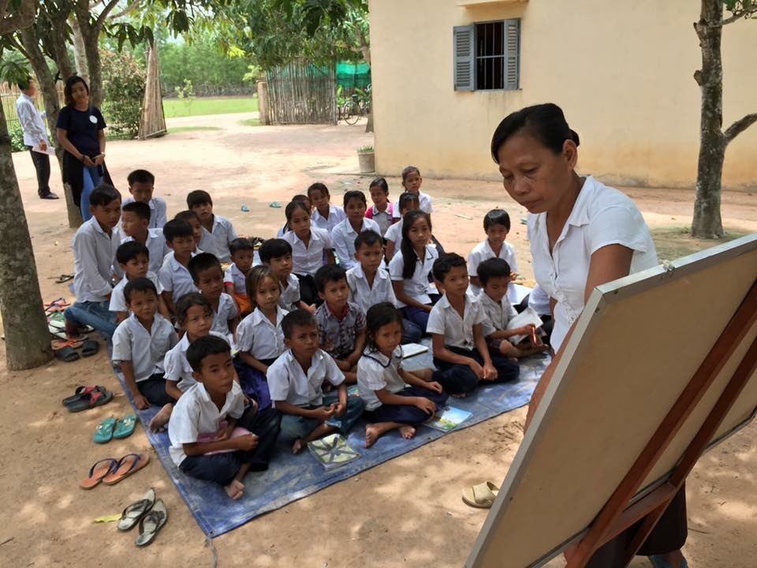
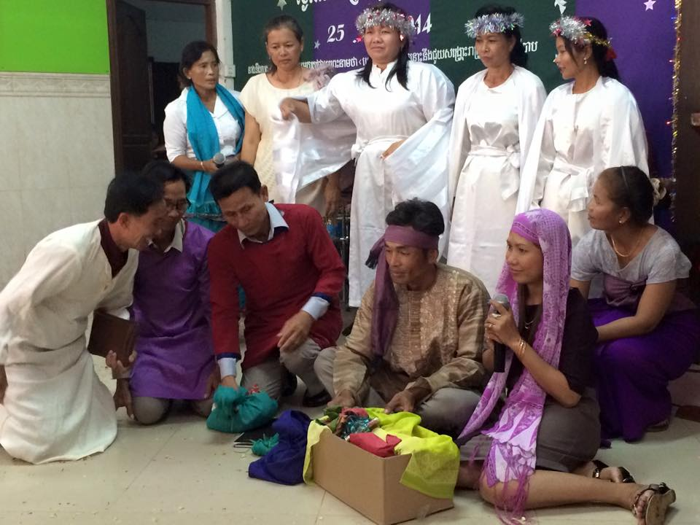
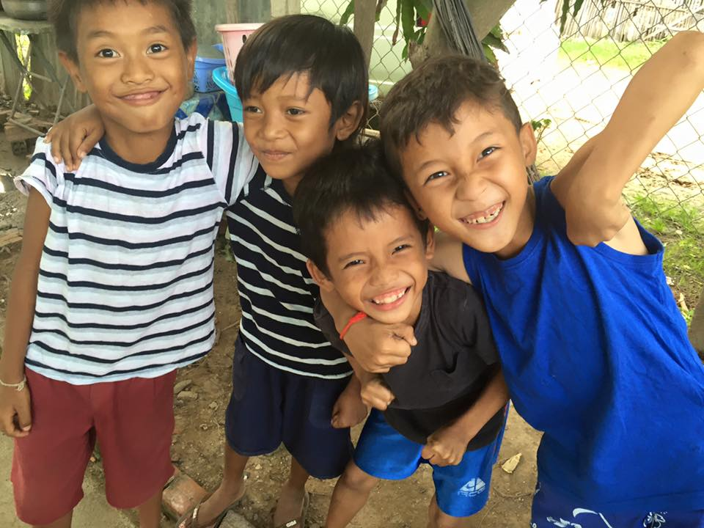

Alternative Gifts
Alternative gifts are a unique way in which you can bless both family and friends, and young people who are in need.  They provide much needed support for village projects in Cambodia.  When you purchase an alternative gift from Care for Cambodia, 100% of the money goes to people who are in need. All administration is completed by volunteers in order to provide as much support as possible for our Cambodian village projects.  To purchase an alternative gift by cash or cheque, please fill in the order form overleaf. Alternatively, if you wish to pay by credit/debit card you can place your order online at www.careforcambodia.org.kh .  You will then be send a gift card which you can send to the recipient of your choice. If you would like to include more than one gift in the same card, please note this on the order form. |  | An example of a CfC Alternative Gift card  An example of the inside of a CfC Alternative Gift card  Thank you for your support!
Alternative Gifts Order Form
To purchase an alternative gift, please fill in the order form below:
Gift |  | Price | Quantity | Total Cost
Sponsor a teacher (Each teacher provides daily lessons for up to 40 children) £25 per month | 1 month | £25.00
 | 2 months | £50.00
 | ___ months
Village Essentials Pack (including water filter and tarpaulin) |  | £24.00
Teachers’ Education Pack (including whiteboard set and ink refills) |  | £17.00
Children’s Education Pack (including blackboards, pens and books) |  | £20.00
Hygiene Pack (including towels, soap and head lice shampoo) |  | £23.50
Sports Pack (including football, volleyball, kicking shuttlecocks and skipping rope) |  | £15.00
Water Filter |  | £12.00
Tarpaulin |  | £12.00
Whiteboard Set |  | £9.00
Whiteboard Pen Ink |  | £8.00
Khmer Bible |  | £5.00
Children’s Towels |  | £10.00
Head Lice Treatment |  | £7.50
Children’s Blackboards |  | £12.00
Box of Pens |  | £2.00
Exercise Books |  | £6.00
School Pupil of the Month Awards |  | £5.00
Football |  | £6.00
Volleyball Set |  | £6.00
Skipping Rope |  | £2.00
 |  | Total Cost

Name: _________________________________________
Address (including postcode):
__________________________________________________________________________________________________________________________________________
Would you like us to gift aid this charitable donation? (Allow us to increase your donation by 25%) Please tick here ☐.
Cheques should be made payable to ‘Care for Cambodia’.
Completed forms should be returned to:
CFC Alternative Gifts, 12 Tullynagardy Avenue, Newtownards, Co Down, Northern Ireland, BT23 4ZE.

